Terra – Conceptual Data Model (Schema) v1.0
This is a conceptual schema diagram showing the key entities and how they relate across phases. It is intended to guide database and API design (not prescribe implementation details).
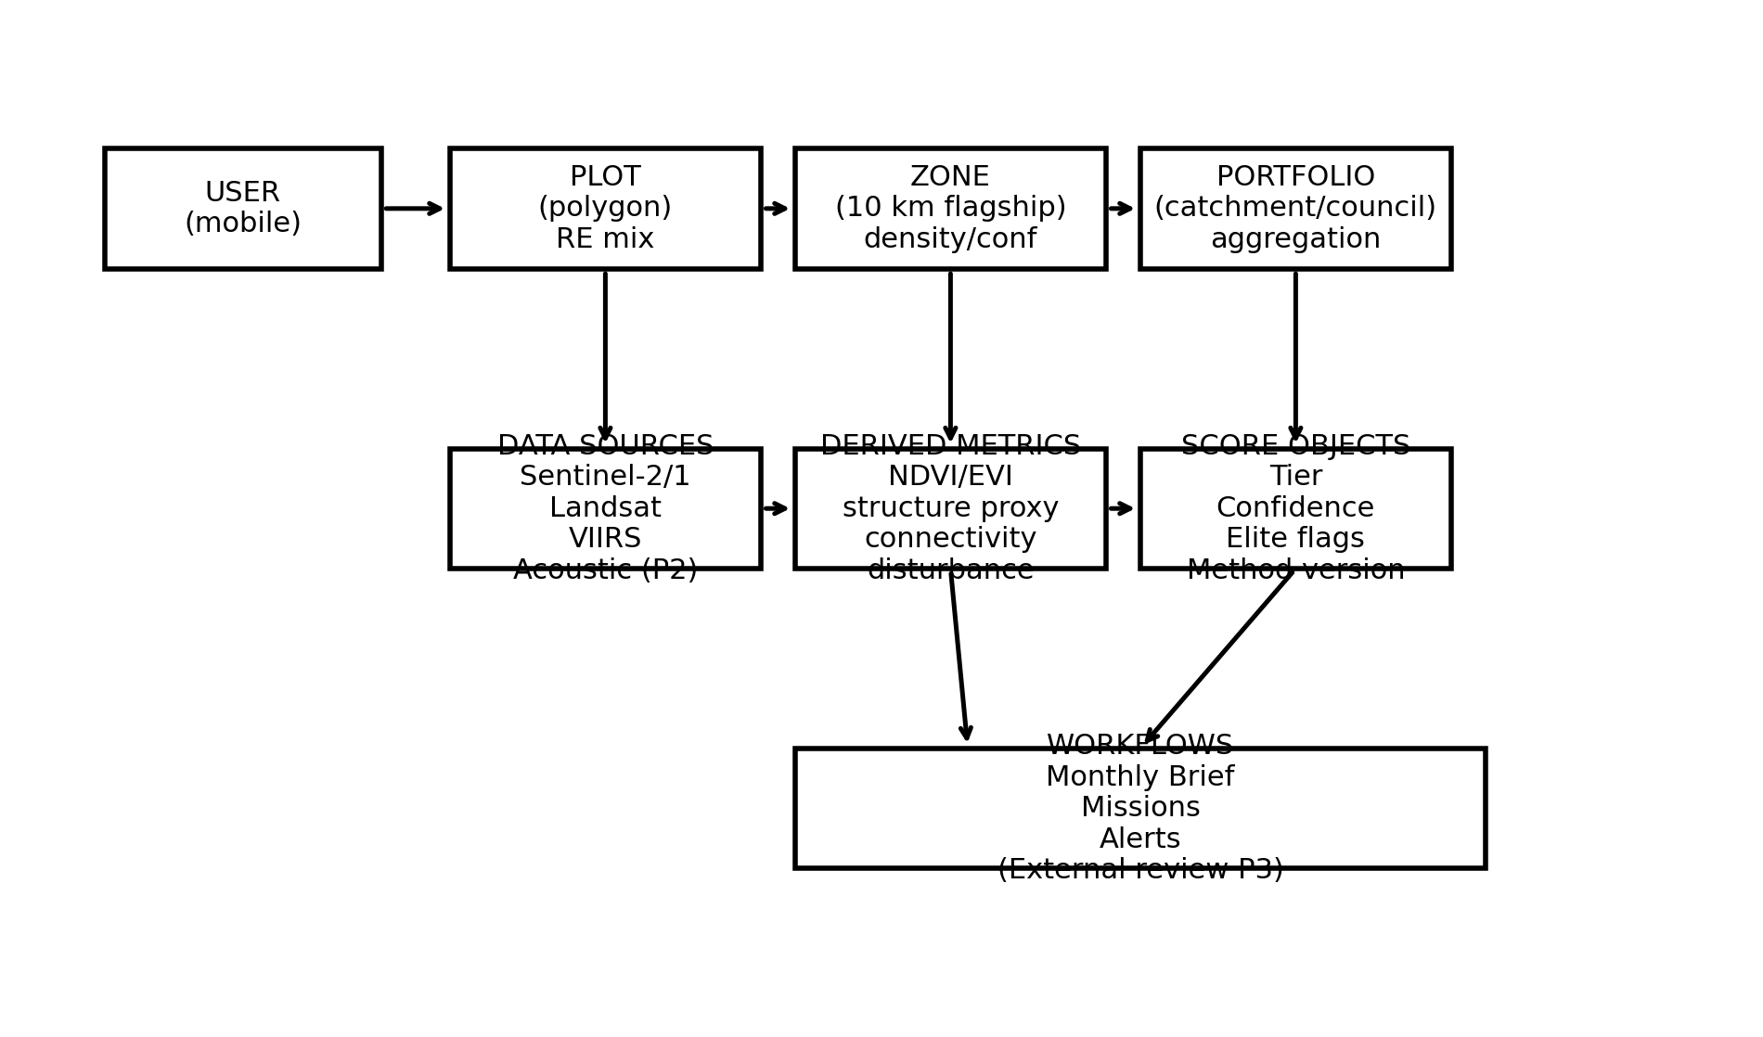

Key Notes
• Plot → Zone → Portfolio hierarchy is mandatory for future market activation.
• Tier/Confidence/Elite flags exist from Phase 1, even if dormant in UI.
• Derived metrics are versioned to keep results reproducible across method upgrades.
• Workflows (briefs, missions, alerts) are driven by derived metrics + score objects.

